Министерство образования Республики Беларусь

Учреждение образования

БЕЛОРУССКИЙ ГОСУДАРСТВЕННЫЙ УНИВЕРСИТЕТ  
ИНФОРМАТИКИ И РАДИОЭЛЕКТРОНИКИ

Факультет компьютерных систем и сетей

Кафедра электронных вычислительных машин

Дисциплина: Оборудование компьютерных сетей

ОТЧЕТ

по лабораторной работе № 4

ВАРИАНТ 11

Выполнил: А.Н. Климович

Проверил: И.И. Глецевич

МИНСК 2024

**1 ПРАКТИЧЕСКАЯ ЧАСТЬ**

**1.1 Часть рабочей конфигурации N1**

interface FastEthernet0/1

switchport trunk allowed vlan 10,20,30,40,50,100

!

interface GigabitEthernet0/1

switchport trunk allowed vlan 10,20,30,40,50,100

!

interface GigabitEthernet0/2

switchport trunk allowed vlan 10,20,30,40,50,100

**1.2 Часть рабочей конфигурации N2**

interface FastEthernet0/1

switchport trunk allowed vlan 10,20,30,40,50,100

!

interface FastEthernet0/2

switchport trunk allowed vlan 10,20,30,40,50,100

!

interface FastEthernet0/3

switchport trunk allowed vlan 10,20,30,40,50,100

**1.3 Часть рабочей конфигурации N3**

interface FastEthernet0/1

switchport trunk allowed vlan 10,20,30,40,50,100

!

interface FastEthernet0/2

switchport trunk allowed vlan 10,20,30,40,50,100

!

interface FastEthernet0/3

switchport access vlan 10

switchport mode access

!

interface FastEthernet0/4

switchport trunk native vlan 10

switchport trunk allowed vlan 10,20,30,40,50,100

switchport mode trunk

!

interface FastEthernet0/5

switchport trunk native vlan 10

switchport trunk allowed vlan 10,20,30,40,50,100

switchport mode trunk

!

interface GigabitEthernet0/1

switchport trunk native vlan 10

switchport trunk allowed vlan 10,20,30,40,50,100

switchport mode trunk

**1.4 Часть рабочей конфигурации N4**

interface Port-channel1

switchport trunk allowed vlan 10,20,30,40,50,100

!

interface FastEthernet0/1

switchport trunk allowed vlan 10,20,30,40,50,100

!

interface FastEthernet0/2

switchport trunk allowed vlan 10,20,30,40,50,100

!

interface GigabitEthernet0/1

switchport trunk allowed vlan 10,20,30,40,50,100

!

interface GigabitEthernet0/2

switchport trunk allowed vlan 10,20,30,40,50,100

!

**1.5 Часть рабочей конфигурации N5**

interface GigabitEthernet0/1

switchport trunk allowed vlan 10,20,30,40,50,100

**1.6 Часть рабочей конфигурации N6**

interface FastEthernet0/4

switchport trunk allowed vlan 10,20,30,40,50,100

!

interface GigabitEthernet0/1

switchport trunk allowed vlan 10,20,30,40,50,100

**1.7 Часть рабочей конфигурации N7**

interface FastEthernet0/1

switchport trunk allowed vlan 10,20,30,40,50,100

!

interface GigabitEthernet0/1

switchport trunk allowed vlan 10,20,30,40,50,100

!

interface GigabitEthernet0/2

switchport trunk allowed vlan 10,20,30,40,50,100

**1.8 Часть рабочей конфигурации N8**

~~ip dhcp excluded-address 107.3.38.209~~

~~ip dhcp excluded-address 107.3.38.210~~

~~ip dhcp excluded-address 197.18.46.33~~

~~ip dhcp excluded-address 197.18.46.34~~

~~!~~

~~ip dhcp pool net_1_pool~~

~~network 107.3.38.208 255.255.255.240~~

~~default-router 107.3.38.209~~

~~ip dhcp pool net_2_pool~~

~~network 197.18.46.32 255.255.255.224~~

~~default-router 197.18.46.33~~

~~!~~

spanning-tree vlan 10,20,30,40,50,100 priority 24576

!

interface Port-channel1

switchport trunk allowed vlan 10,20,30,40,50,100

!

interface FastEthernet0/1

switchport trunk allowed vlan 10,20,30,40,50,100

!

interface FastEthernet0/2

switchport trunk allowed vlan 10,20,30,40,50,100

!

interface Vlan40

mac-address 00d0.ba90.3c04

ip address 107.3.38.209 255.255.255.240

ip helper-address 9.192.0.13

!

interface Vlan50

mac-address 00d0.ba90.3c05

ip address 197.18.46.33 255.255.255.224

ip helper-address 9.192.0.13

!

**1.9 Настройка Tablet PC0**

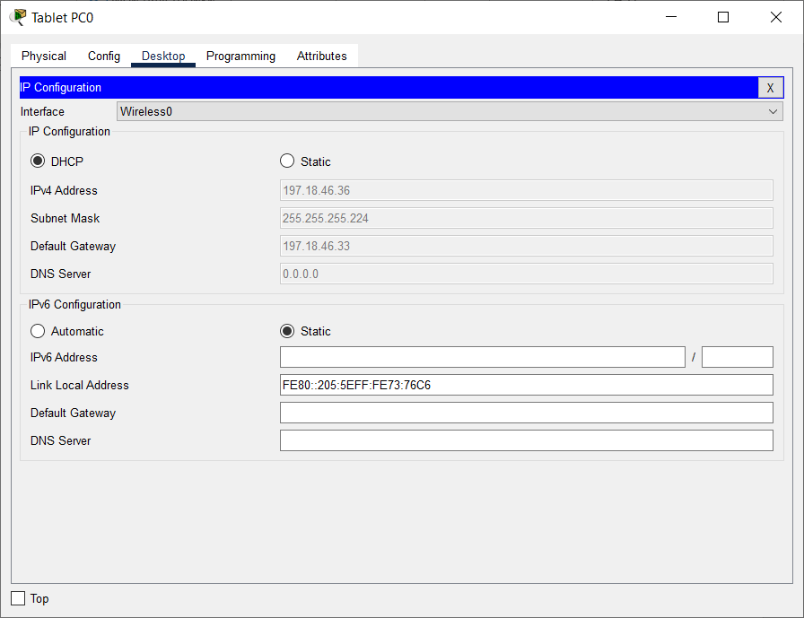

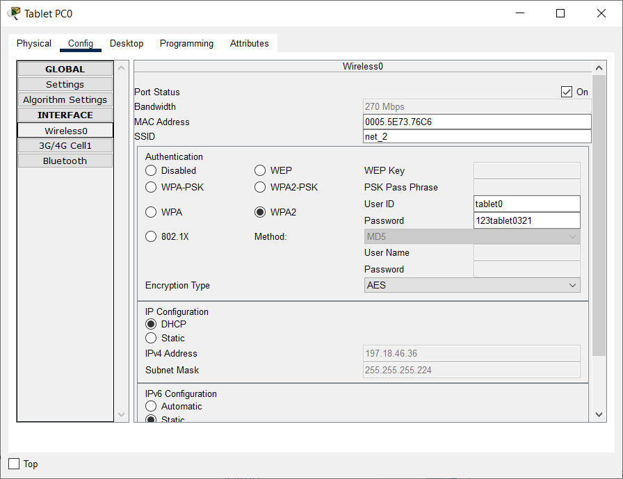

**1.10 Настройка Smartphone0**

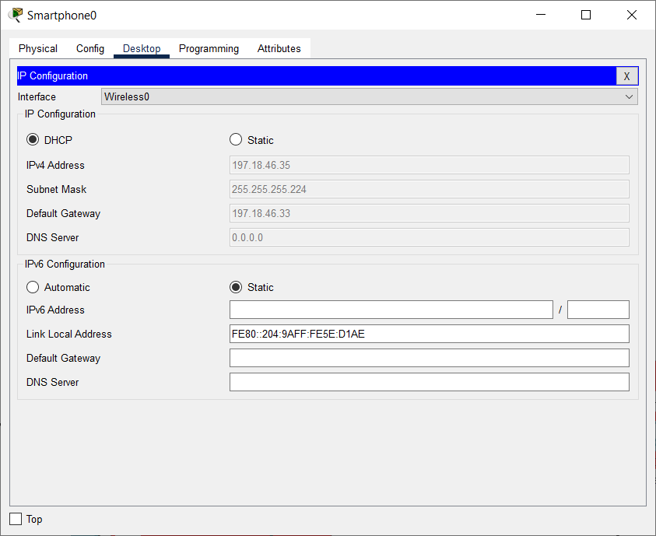

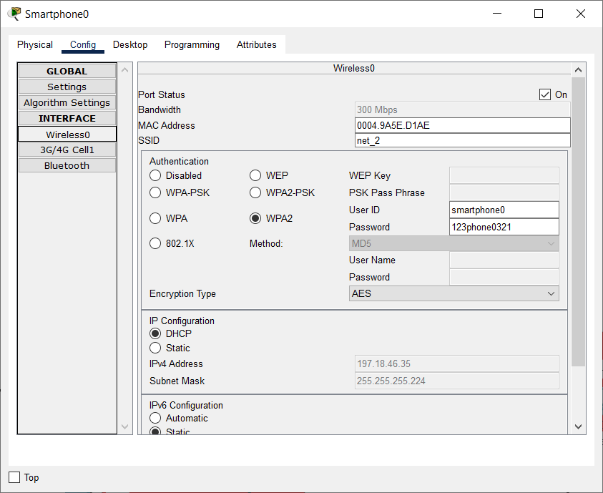

**1.11 Настройка Laptop3**

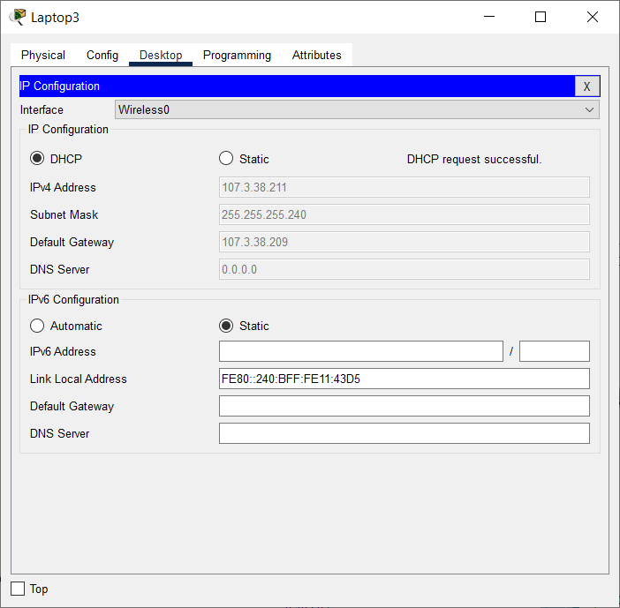

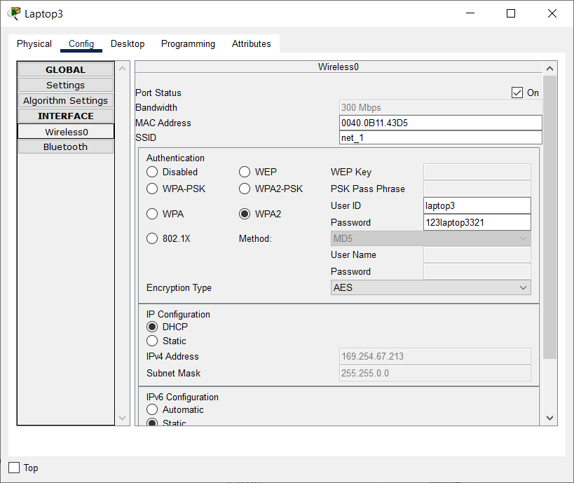

**1.12 Настройка LWAP-1 (3702i)**

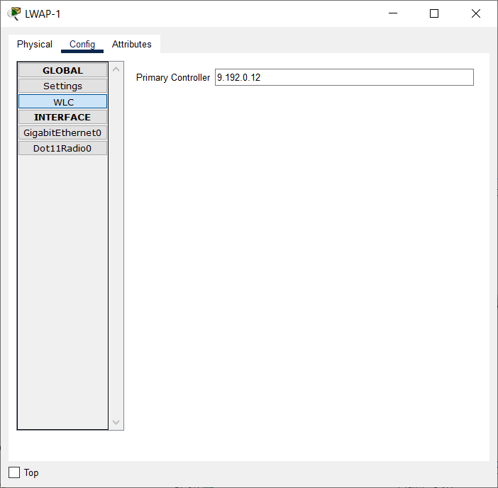

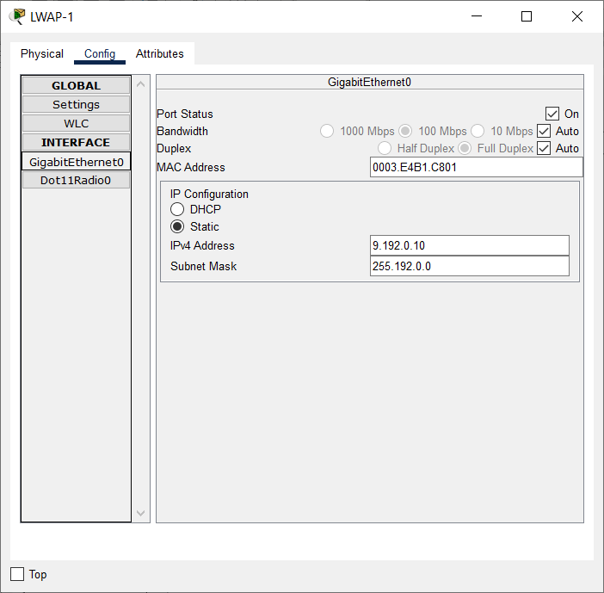

**1.13 Настройка LWAP-2 (3702i)**

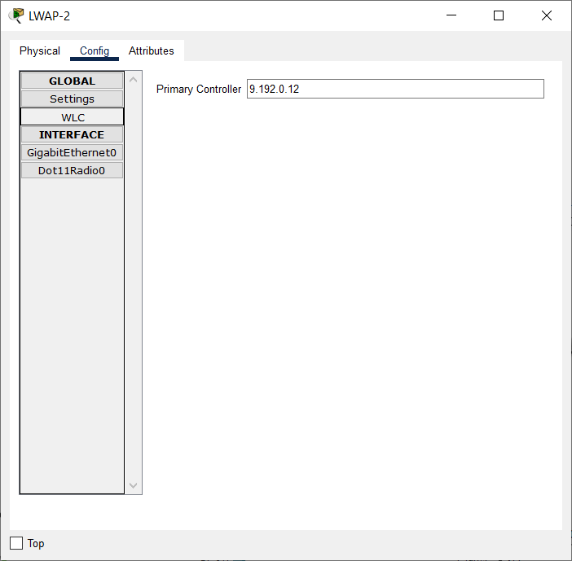

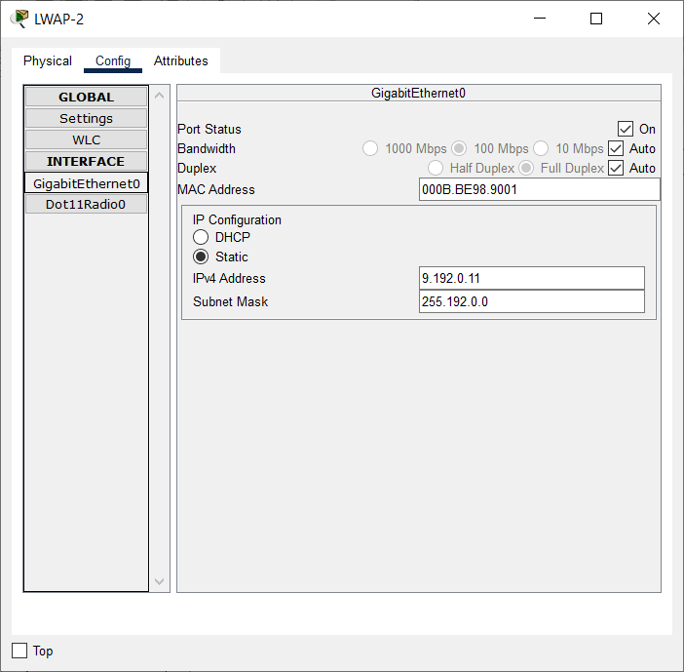

**1.14 Настройка Server0**

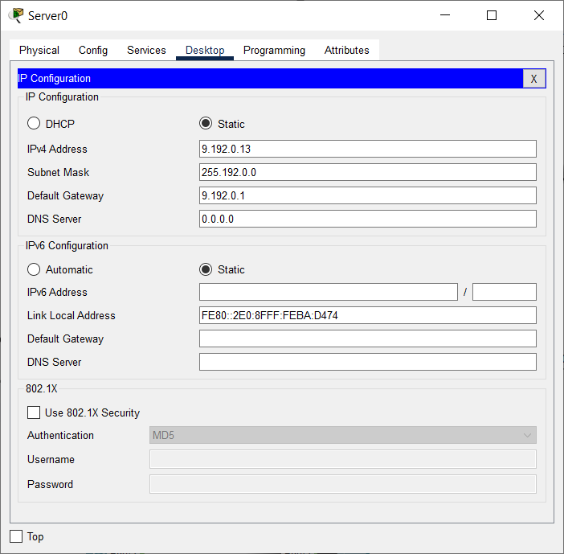

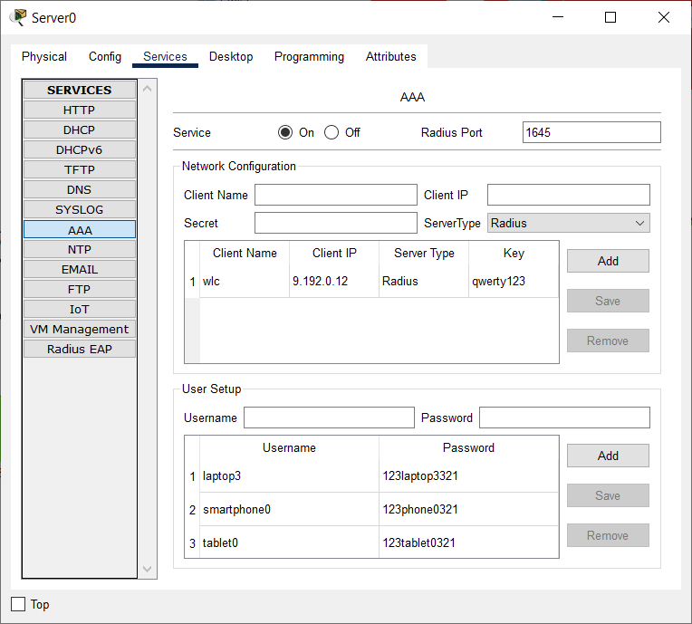

Если DHCP на сервере:

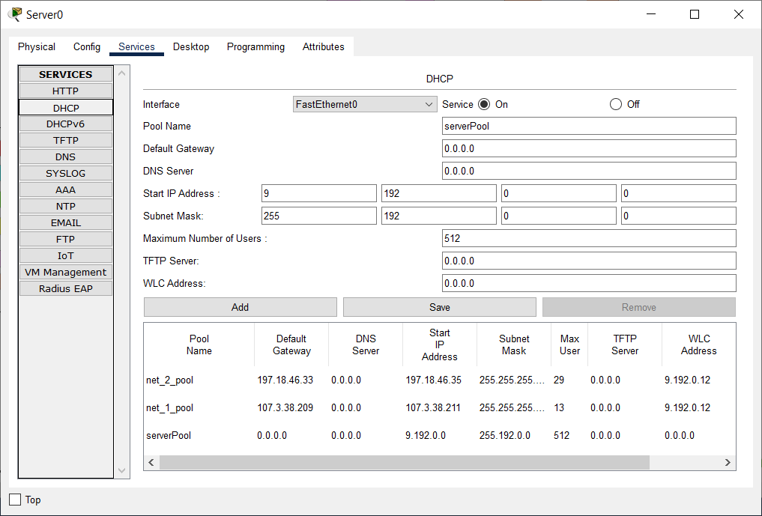

**1.15 Настройка WLC-3504**

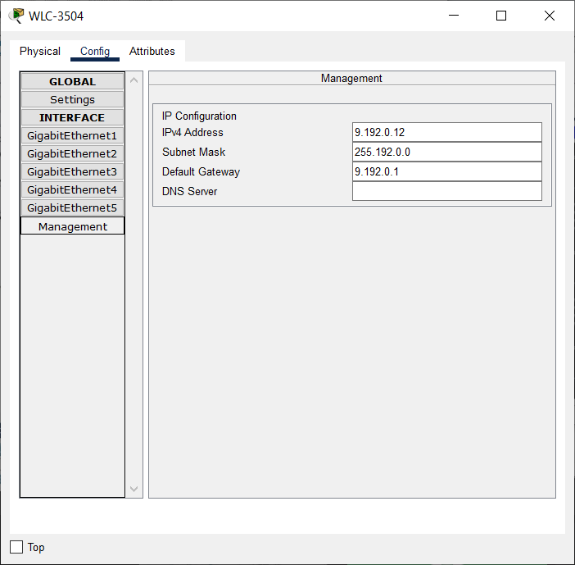

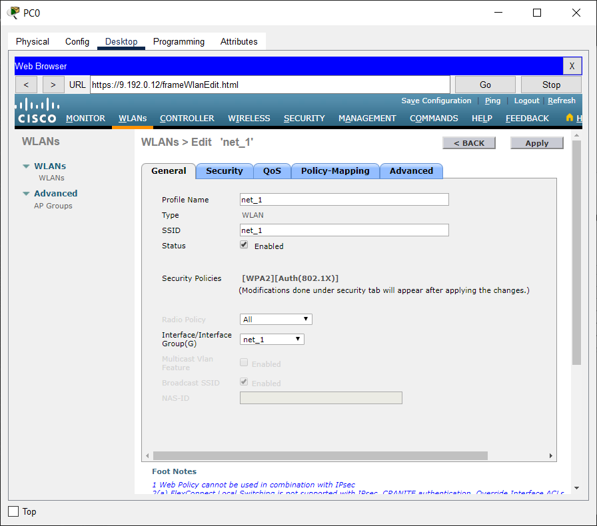

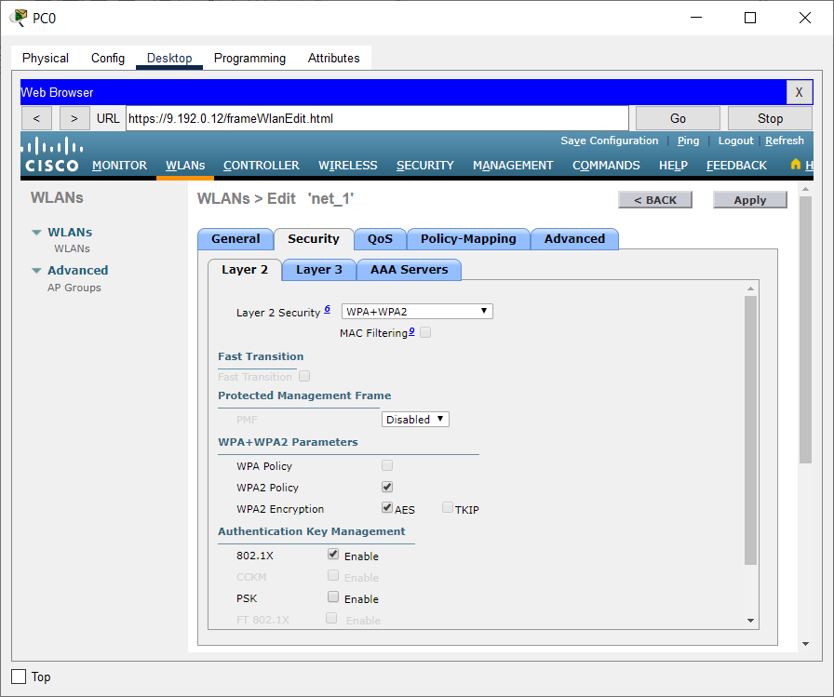

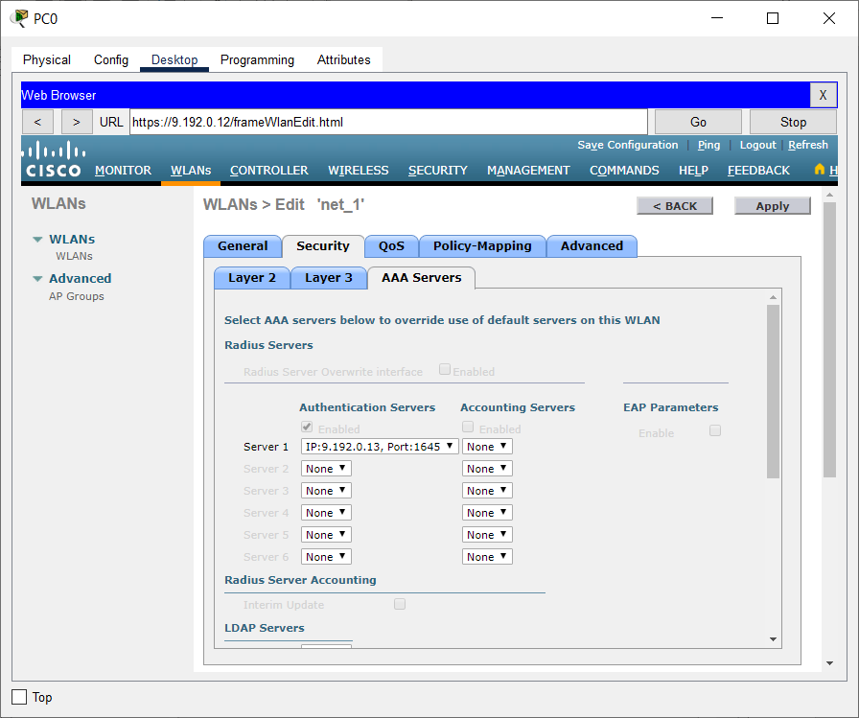

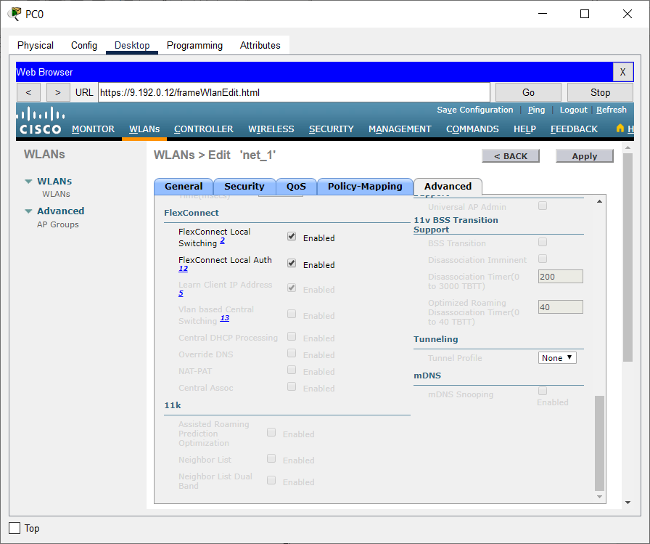

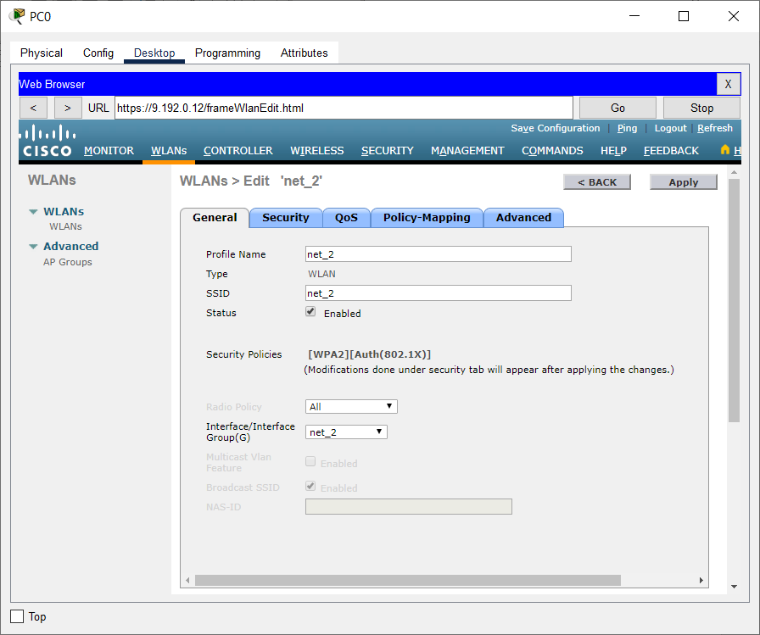

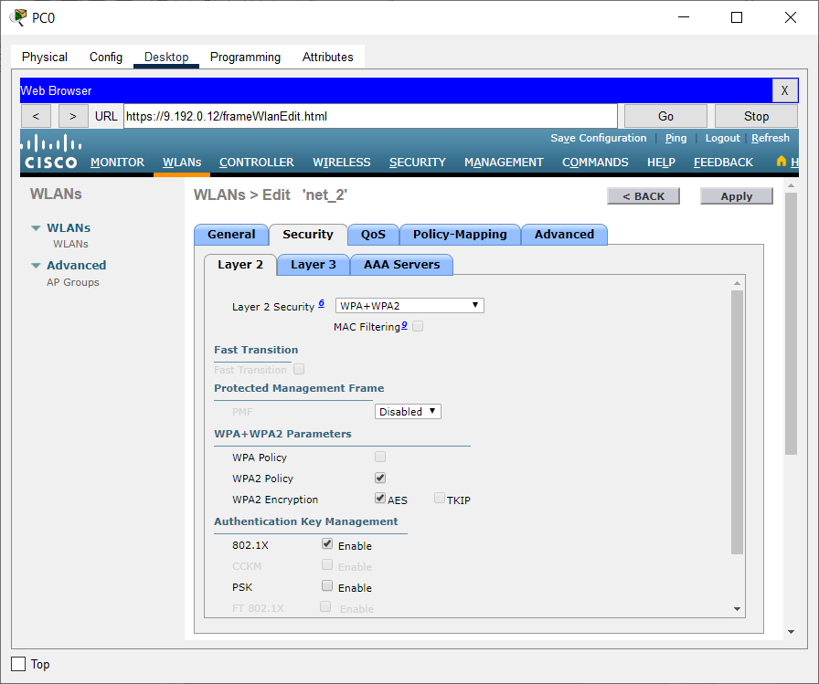

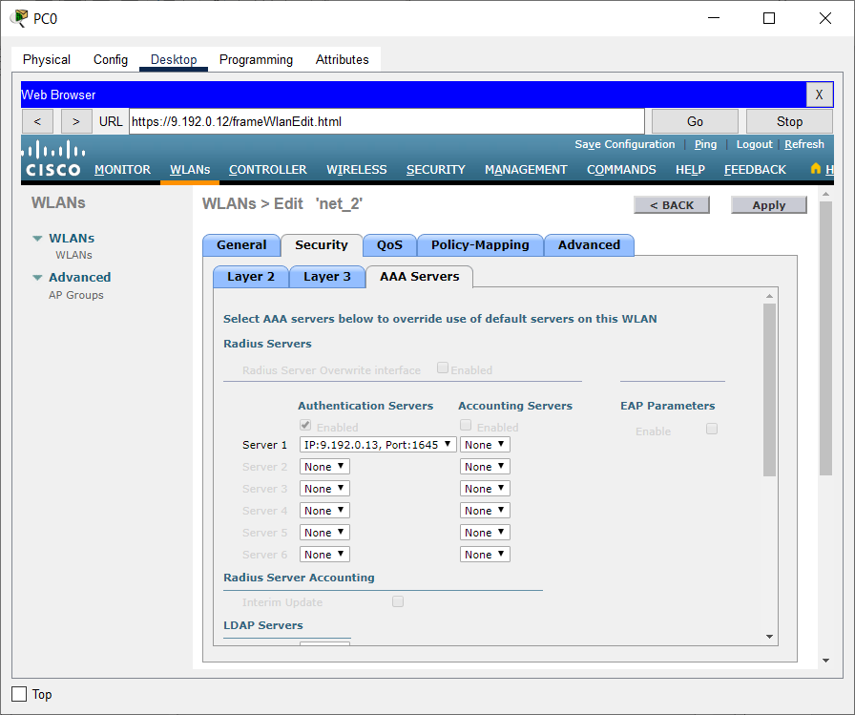

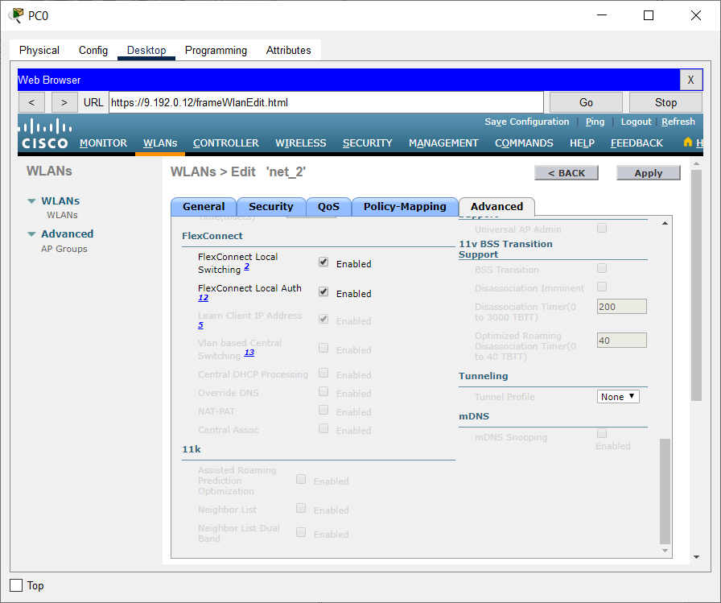

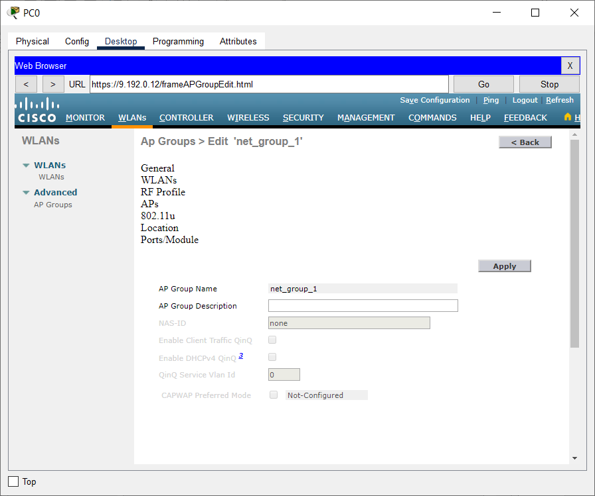

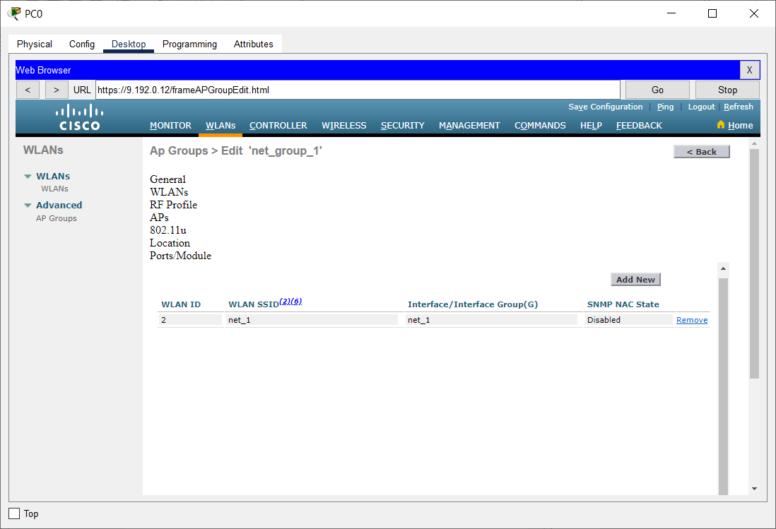

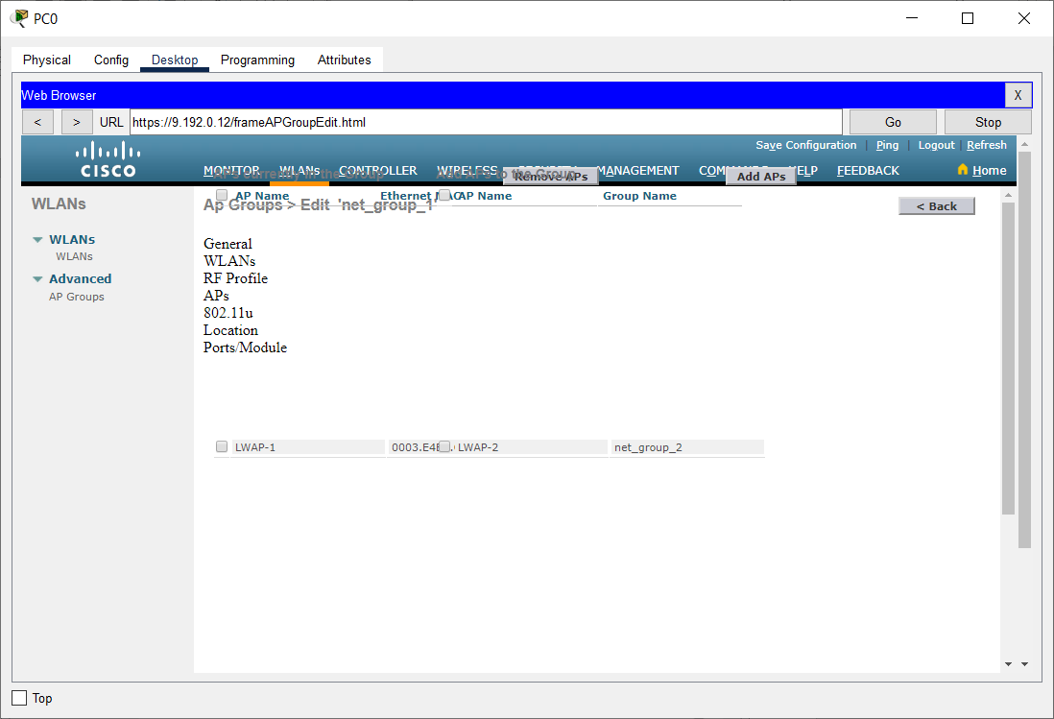

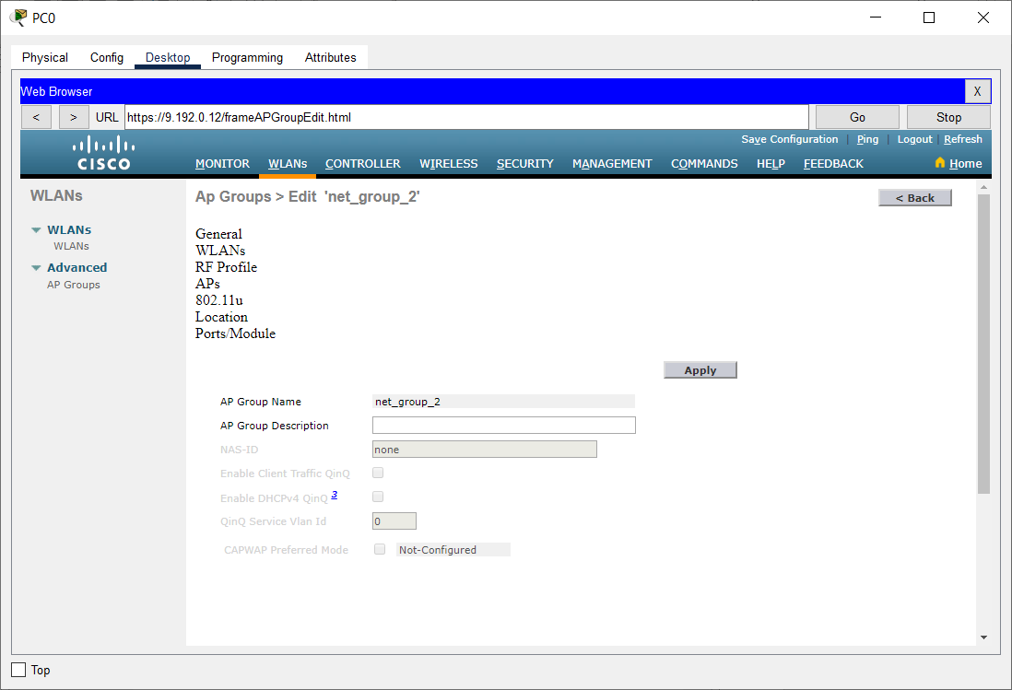

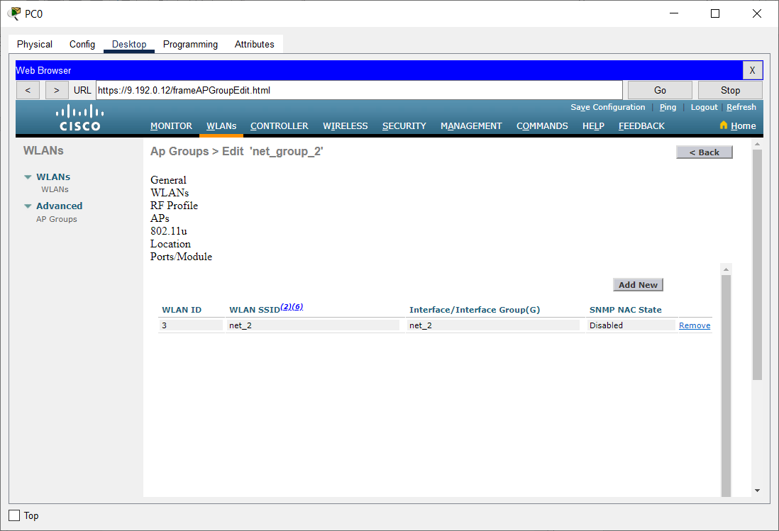

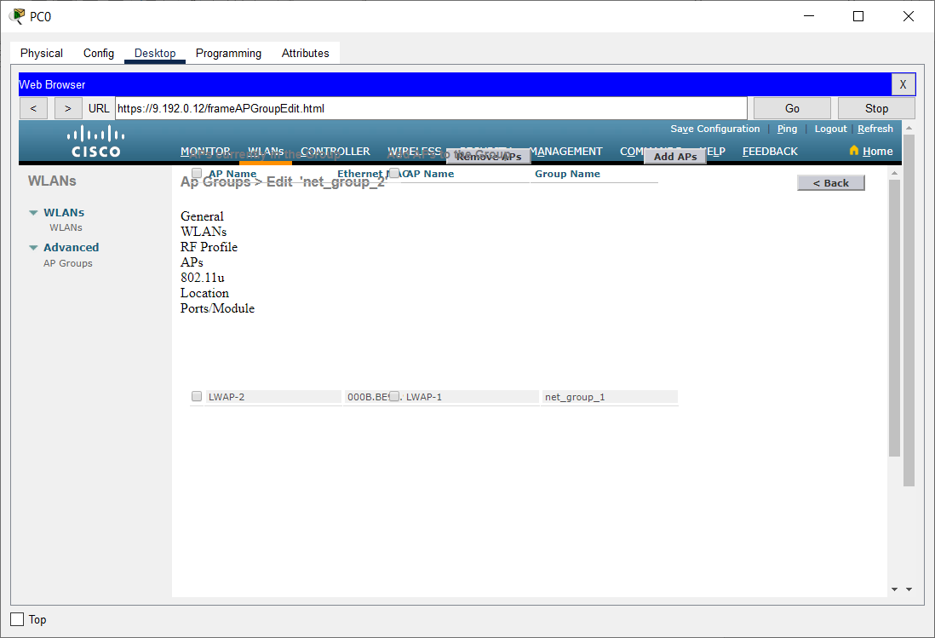

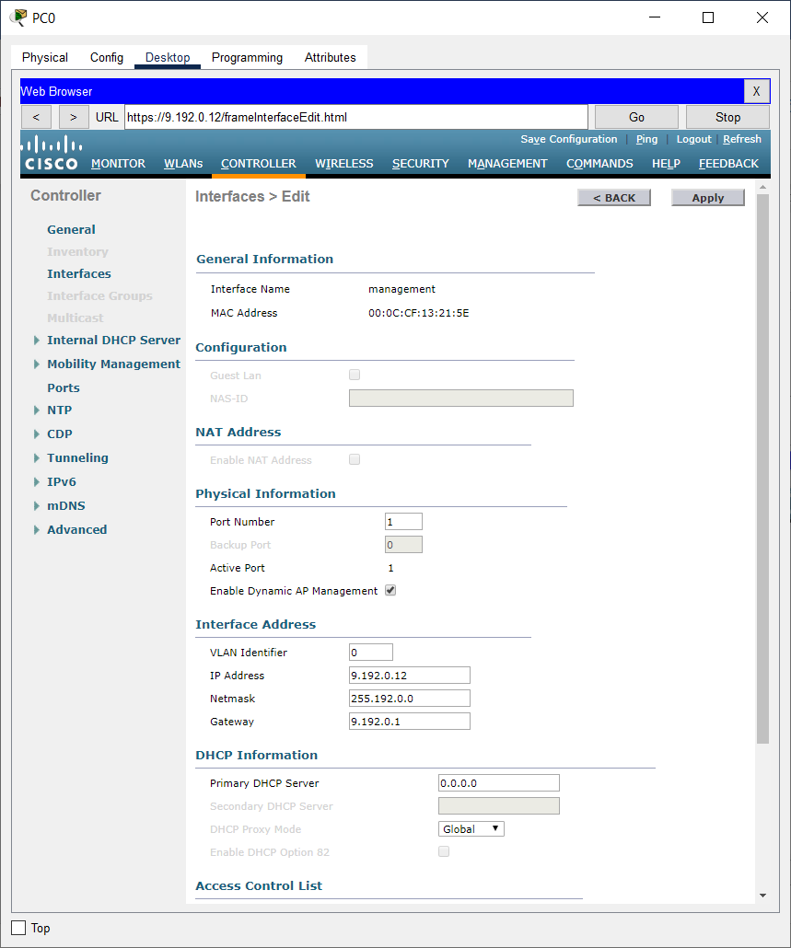

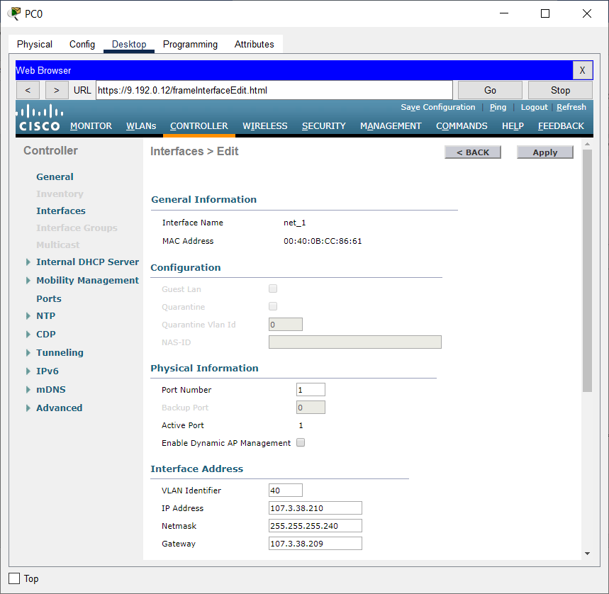

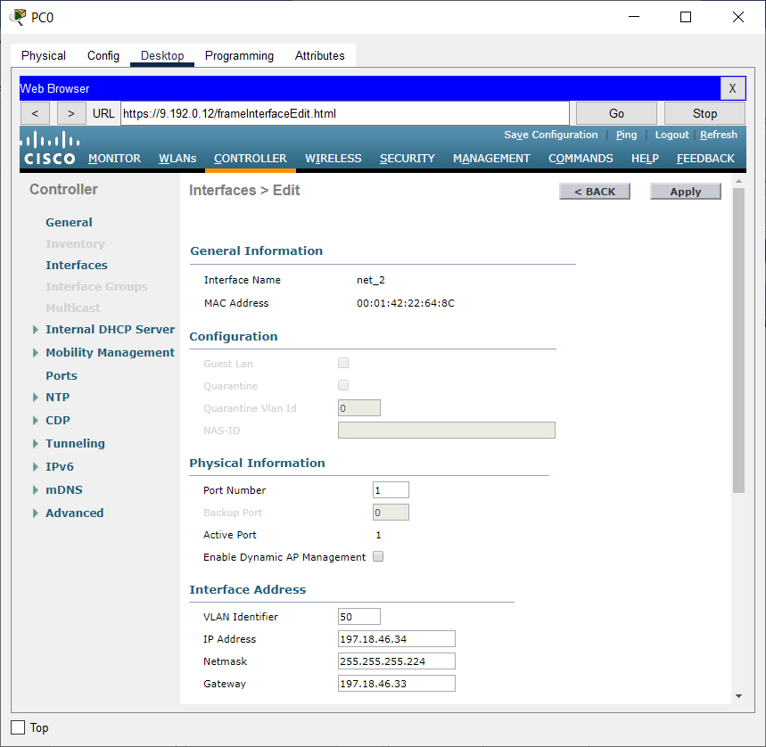

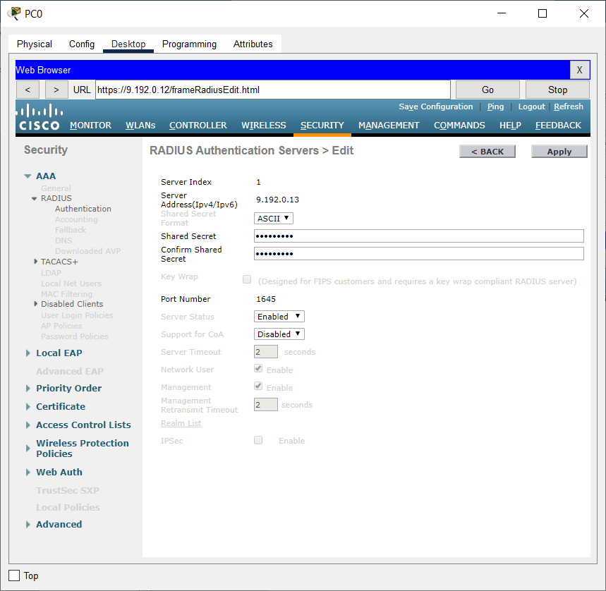

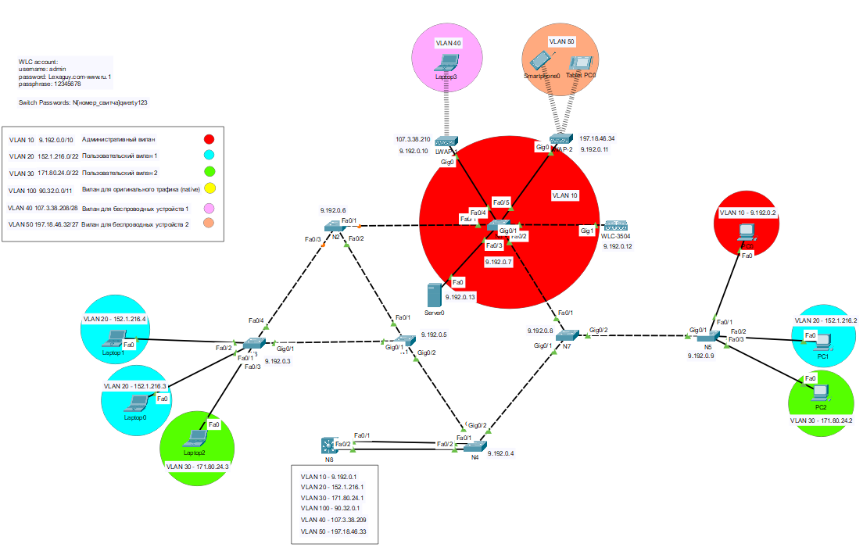**РАБОЧИЕ МАТЕРИАЛЫ**